Visit Rowallan Camp in Kenya
Student’s Name
Institution
Date
Visit Rowallan Camp in Kenya
I traveled to the Rowallan Camp, located on the outskirts of the Kenyan capital of Nairobi. Visiting the camping site for the first time made me anxious and happy to enjoy the new place. I traveled with friends to ensure our two days camping got fun and exciting. Visiting Rowallan Camp was exciting and engaging to me because other people came to the site. I could mingle with different people and have fun that increased my love for activities that got performed. Also, there were monkeys at the camp that allowed me to enjoy interacting with the animals. I engaged the monkeys by giving them bananas and snacks to feed on at the site. It was a pretty interaction that I had never felt before with other monkeys. I did not get hurt by any monkeys because I never showed any aggression towards them. Camping at Rowallan is fun and exciting because of the many activities that get undertaken. My friends and I commenced the event by setting tents that would get used as shelter at night. Setting the tents got done in a way that space got left for bonfire adventure. I took a photo of the area as I posed with different people and the monkeys in the background. I felt much fun that increased my confidence to mingle with others and enjoy the new activities in the area. As a first-time visitor, I could feel the whirling of wind moving trees back and forth with cool air hitting my face. II was amazed to breathe the cool air that existed in the forest within the camp. Trees swayed from side to side, an indication that purified atmosphere existed.
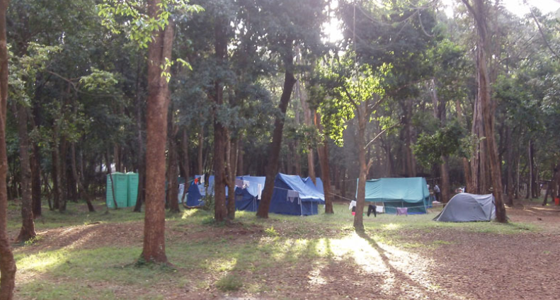
Figure 1:Rowallan Camp
Moreover, team-building activities got undertaken with all the groups working together within the camping site. Music got played as people danced to all sorts of beats that got produced. I wined while dancing to ensure team-building exercises get exciting. Team building activities enhanced bonding amongst the campers. I got to know people from other camps who joined to make the event glamorous. It was now approaching 7 P.M, and the noise of people having fun rented the air. I was excited and happy to have been amongst the campers. Bourdain showed how interesting a place could get through the kind of events performed. He developed attributes of fun that led to the creation of joy amongst people. Cooking meat and raising a glass of drink got done in a wondrous manner that developed fun amongst people. Bourdain made the use of humor that helped make the events of his writing exciting. He mentioned that people need to leave demons away and enjoy themselves in various events. The sense of humor made his work profound for reading.
I engaged other friends to commence lighting the bonfire, given that it was getting a night with some cold setting in the forest. The monkeys were quickly leaving for their homes as the dark started to unfold. I agree with the proverb, "East or west home is the best." The bonfire was ready, and pieces of meat were getting marinated to get grilled on fire. Excitement was reaching its peak, and I hurriedly went for my warm clothes to increase body heat. It was getting cold in the camping site, but the bonfire helped create warmth that made the evening fun enjoyable. I felt thrilled internally with other people getting friendly to ensure maximum enjoyment got achieved. The friendly relationship made me feel accepted by new people, and the positive mindset for the event increased. The cold at Rowallan Camp increased, but some revelers walked bare-chested to gyrate their bodies to musical beats. It was a fun met adventure with people drinking, eating, singing, dancing, and socializing.
Fatigue took the better part of me at around 3:30 in the morning, and I made it to my camp to take a nap. Other revelers continued with the event till the sky became clear. The chilling wind was intense that people felt their skin getting pricked. I stood up feeling tired and headed to the kitchen, where an excellent breakfast got prepared. I got served tea, bread, egg, and a banana to ensure we got the strength for the day's events. People gathered around the round table, making funny jokes about the night's events. A friend of mine was as funny as a barrel of monkeys. He cracked jokes that kept people laughing the entire time of eating. The breakfast got well prepared that people ate before going for the nature walk. I made the nature walk in the forest and enjoyed parts of the cave in the camp. I was strong as an ox when moving in the dense forest and rocky caves. There was a river that wounded through the forest that made the scene remarkable. Swimming could get done by anybody who felt to cool their body after the tiresome walk.

